Looking Forward to Pie
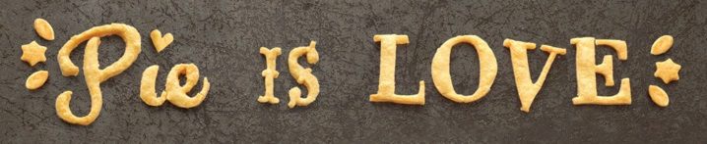
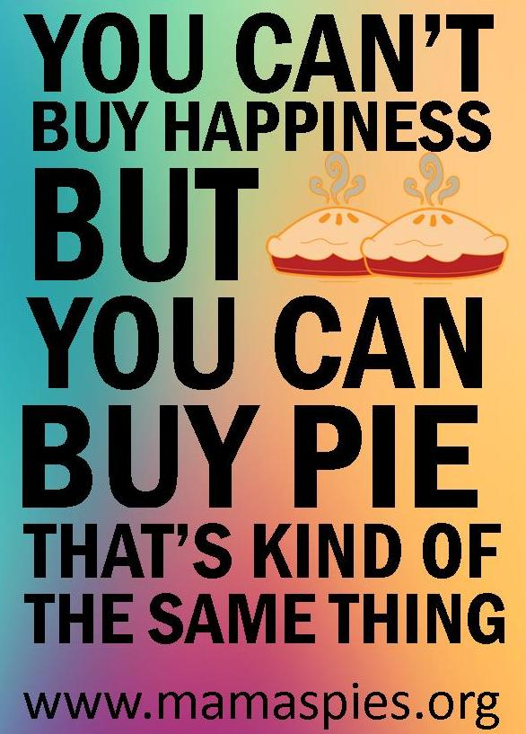
Even though it’s still summer, the Fall months will be here before you know it. The scent of pie will be wafting through the halls of Mama’s Kitchen, and our Pie in the Sky fundraiser will be in full swing! Each year, generous bakers donate apple, pumpkin, pecan and Dutch apple pies that are sold by our dedicated supporters for $25 each. Every pie purchased provides seven nutritious meals—a week’s worth of dinners—for one of our clients. With the help of our presenting sponsor, Wells Fargo, and numerous volunteers and supporters, we hope to raise $108,000 and provide over 32,000 meals for our home bound clients in need of nutrition. Look for our pie sale from October 10th to November 20th. For more information or to order pies, visit www.mamaspies.org.

